**Objective Question**

1. In analyzing the hospital dataset with Power BI, ensure data cleaning to address inconsistencies and missing values before further analysis.

Ans:- Here’s how we approach data cleaning in Power BI for a hospital dataset:

Remove Duplicates: Identify and remove any duplicate entries.

Handle Missing Values: Use Power Query to find missing data in critical fields like patient_age, Appointment Fees, or department_referral. Replace or exclude missing values depending on the analysis goals.

Standardize Data: Ensure consistency in text-based fields like Doctor Name or department_referral by standardizing spellings and formats (e.g., "ER" vs. "Emergency Room").

Correct Data Types: Assign appropriate data types (e.g., date format for date, number format for Appointment Fees, etc.) to avoid calculation errors.

2**.) Assess the Average Waiting Time:** Analyse the patient wait times to identify the average duration a patient spends before receiving care.

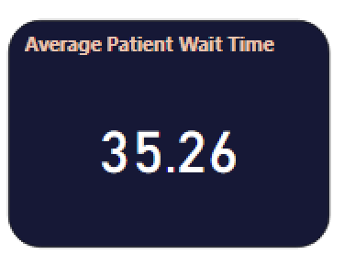

Using DAX function:- Average Patient Wait Time = AVERAGE('Hospital ER'[patient_waittime]) , we can find the average patient wait time which is 35.26 .

3.) **Visits by Department Referral:** Calculate the total number of visits to each department based on referrals to understand which departments are most frequently visited.

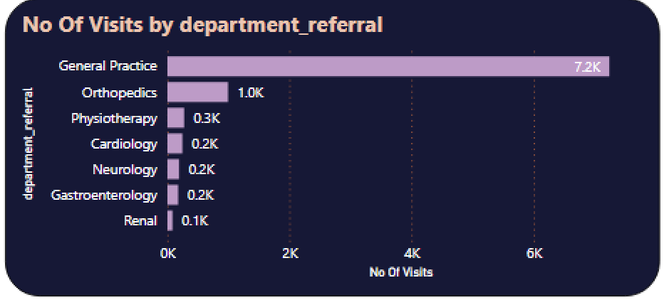

**From the data we can clearly see that General Practice department is most frequently visited with around 7.3 K number of visits, followed by Orthopedics.**

**4.) Patient Visits by Age Group:** Segregate patient visits according to different age groups to see which demographics utilize healthcare services the most.

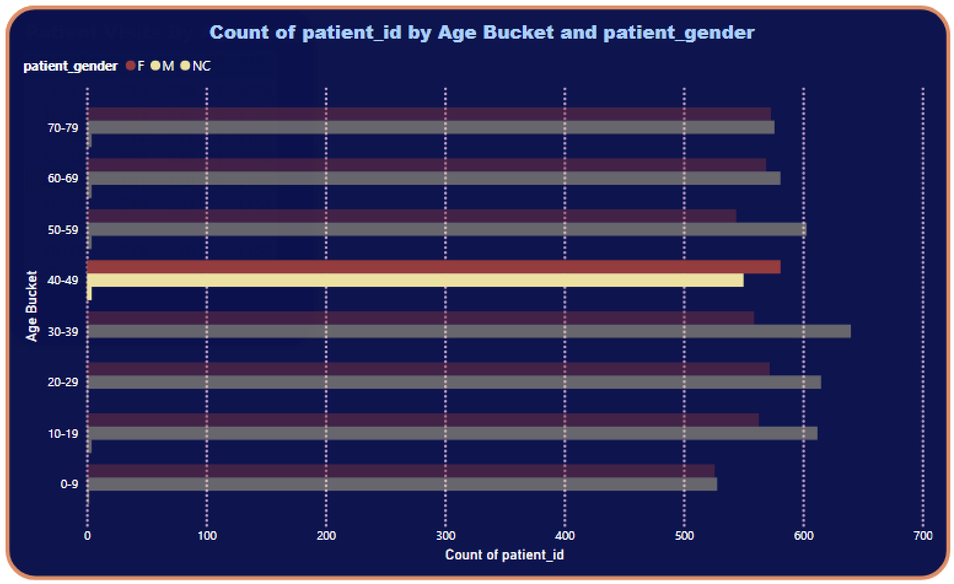

From the data we can clearly see that patients in the age range of 30-39 has highest number of visits which is 1200 in the hospital dominating male patients. After that patients in the age range of 20-29 has 2nd highest visits in the hospital.

5.)Were there any Null values in the data? What would be the best way to handle these Null values and which approach have you opted for?

Ans:-) There were particularly no null values in the data. On clicking on transforming data in power bi desktop we can move to power query editor and when we use check column validity , we can clearly see that almost all the columns are 100 % valid except customer satisfaction . Customer satisfaction column is having considerable amount of null values since it was not affecting the overall data ,calculation and visualization , so we have not removed it . If we have removed it it would have affected the entire table and we wouldn't have got the accurate analysis and visualizations of data.

6.) Is there any relation between the number of visits and the Gender of the patients?

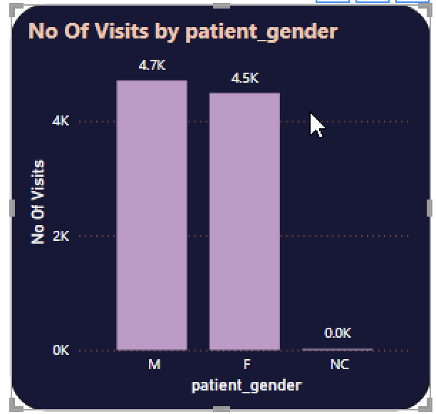

From the data we can clearly see that no. of male visitors in hospital is greater than that of female visitors.

7.) Average Satisfaction by Demographics: Determine the relationship between patient satisfaction scores, their age groups, and racial backgrounds to pinpoint areas for improvement in patient experience.

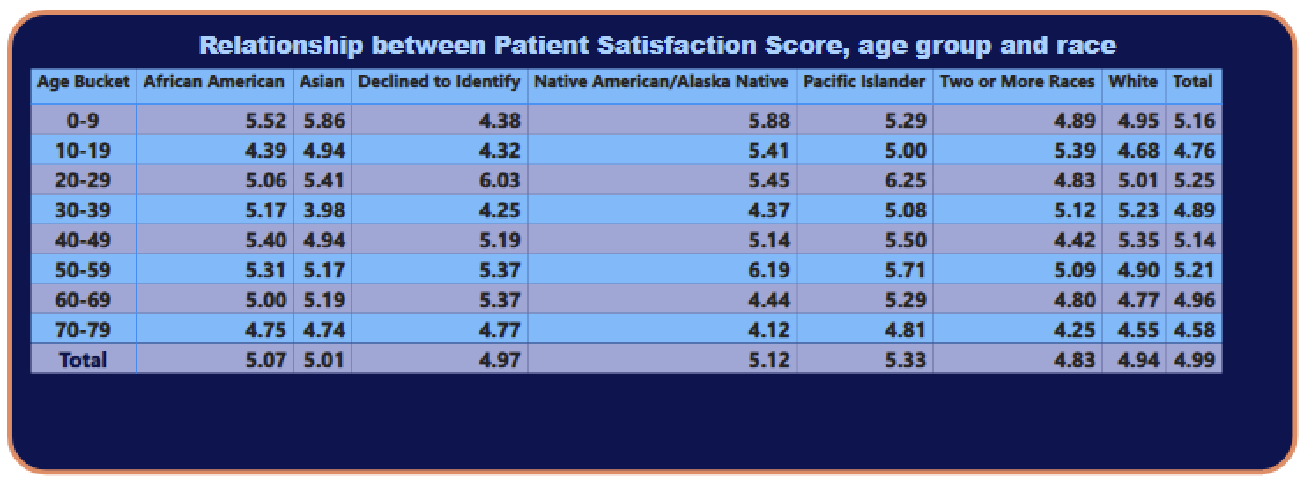

The above matrix shows the relationship between patient satisfaction scores, their age groups, and racial backgrounds to pinpoint.

8.) The hospital's managing director seeks to evaluate the Certainly! Here’s an elaboration on how you can handle data format issues in Power BI:

### **Handling Data Format Issues in Power BI**

**1. Identifying Data Format Issues:**

* Before you can resolve data format issues, it’s essential to identify them. Common issues include:
  + Incorrect data types (e.g., dates stored as text, numbers with commas or currency symbols).
  + Inconsistent formats (e.g., different date formats like MM/DD/YYYY vs. DD/MM/YYYY).
  + Leading or trailing spaces in text fields.

**2. Converting Data Types:**

* In Power BI, data types are crucial for accurate data analysis. To convert data types:
  + **Access Power Query:** Load your data into Power BI, then click on “Transform Data” to open Power Query Editor.
  + **Select the Column:** Click on the column that has the incorrect data type.
  + **Change Data Type:** Use the “Data Type” dropdown in the ribbon to select the appropriate type (e.g., Date, Text, Number). For example:
    - Change a column from Text to Date if the data represents dates.
    - Convert a column from Text to Whole Number if it contains numeric values stored as text.

**3. Standardizing Formats:**

* Once data types are corrected, you may need to standardize the formats to ensure consistency across your dataset. Power Query’s “Transform” tools can help with this:
  + **Using the "Transform" Tools:**
    - **Date Formatting:** Use the "Date" functions to ensure all dates are in a consistent format. For example, you can extract the year, month, or day as needed.
    - **Text Functions:** Remove unwanted characters (e.g., spaces, special symbols) using functions like Text.Trim or Text.Replace.
    - **Number Formatting:** For numbers, ensure that decimal points and thousand separators are consistent. Use functions like Number.Round to control decimal places.
    - **Custom Formats:** You can create custom formats using the “Add Column” feature to derive new columns that meet your specific requirements.

**4. Applying Changes:**

* After making the necessary changes in Power Query, ensure you apply those changes:
  + Click on “Close & Apply” to save the transformations and load the cleaned data back into Power BI.

**5. Validation:**

* Finally, validate your data:
  + Check a few records to ensure that the formats are now correct.
  + Run visualizations or calculations to confirm that the data behaves as expected.

### **Conclusion**

Handling data format issues in Power BI is essential for accurate analysis and reporting. By converting data types and standardizing formats using Power Query's “Transform” tools, you can ensure that your dataset is clean, consistent, and ready for analysis. This process enhances the overall quality of your data, making it more reliable for insights and decision-making.

o understand how much revenue is generated by each.

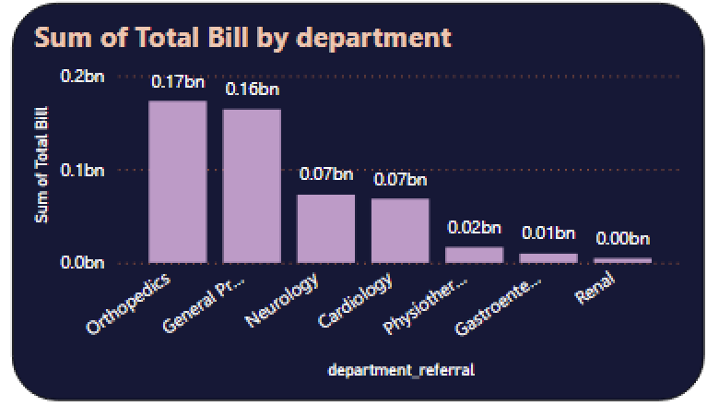

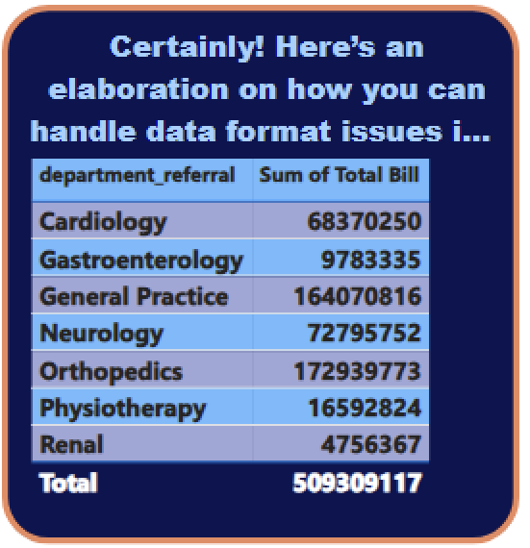

The above visualization clearly shows the revenue of each department . In this we can clearly see that Orthopedics department provides maximum revenue to the hospital followed by General Practice deparment.

9.) Which department is charging the highest appointment fees in general? Use an aggregation DAX function to solve this question.



In this to calculate this we will have to use two DAX functions :- MaxAppointmentFees = MAXX(VALUES('Doctor_Patient_Data'[department_referral]), CALCULATE(MAX('Doctor_Patient_Data'[Appointment Fees])))

And HighestAppointmentFeesDepartment =

CALCULATE(

MAX('Doctor_Patient_Data'[department_referral]),

FILTER(

'Doctor_Patient_Data',

'Doctor_Patient_Data'[Appointment Fees] == [MaxAppointmentFees]

)

)

And from this we can clearly see that Neurology Department has the highest appointment fee in general.

11.) Using ‘Calculate’ and a row iteration DAX function calculate the total number of patients who have visited Dr. Smith.

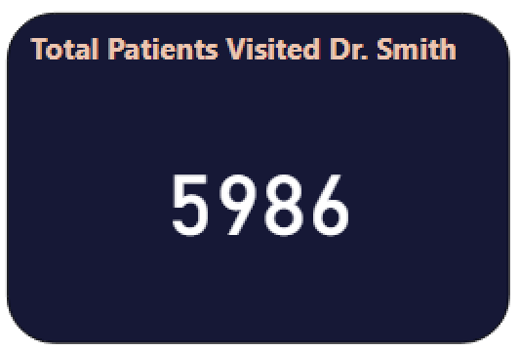

Using this DAX formula we will calculate the total number of patients who have visited Dr. Smith , Total_Patients_DrSmith =

CALCULATE(

COUNTROWS(

FILTER(

'Doctor_Patient_Data',

'Doctor_Patient_Data'[Doctor Name] = "Dr. Smith"

)

)

)

And from the calculation we can clearly see that 5986 is the number of patients visited Dr. Smith.

12.) Calculate the average age of the patients who visit the Orthopedics department. Will the approach used to calculate this metric be different if the requirement had been all departments’ average age?

Ans:- To calculate this we will use two DAX functions.

AverageAgeOrthopedics =

AVERAGEX(

FILTER(

'Hospital ER',

'Hospital ER'[department_referral] = "Orthopedics"

),

'Hospital ER'[patient_age]

)

And

AverageAgeAllDepartments = AVERAGE('Hospital ER'[patient_age])

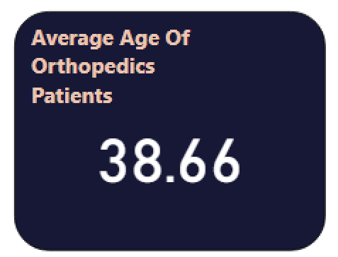

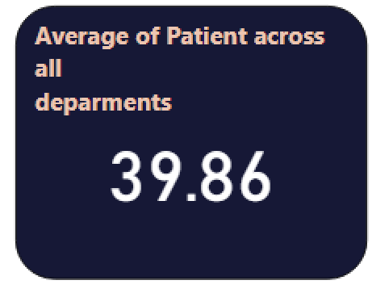

Ans:- Yes, the approach used to calculate the metric would have been different , if the requirements is for all department’s average age.

Key Differences in Approach

**Filtering**: The primary difference in the approach is the use of the FILTER function to restrict the data to the Orthopedics department. For the average across all departments, you do not apply any filter.

**Simplicity:** The calculation for all departments is simpler as it doesn’t require filtering. You directly average the patient_age column across the entire dataset.

13.) Were there any data format issues in the data, and if there were/are how you handle them?

Ans:-

Yes, there were data format issues in data i resolved them using power bi query editor for below given data.

1. Date Format:- I have changed the date format from date-time to date and time in separate columns.
2. Extracting Year from Date :- To analyze the data on a year basis, in this i have extracted year from date.
3. Extracting Month Year from Date: To analyze the data on a month-year basis , in this i have extracted month year from date.

14.) When we add a column in Power Query what’s the code that comes in M language in the formula bar? What do you know about M-query?

Ans:-) When we add a column in Power Query, the code in the M language formula bar typically starts with a function like Table.AddColumn. M-query is a functional, case-sensitive language used in Power Query for data manipulation, designed for efficient data transformation and retrieval. It allows for step-by-step transformations applied to the data.

**Subjective:-**

1. What is the relation between patient wait time and satisfaction scores?

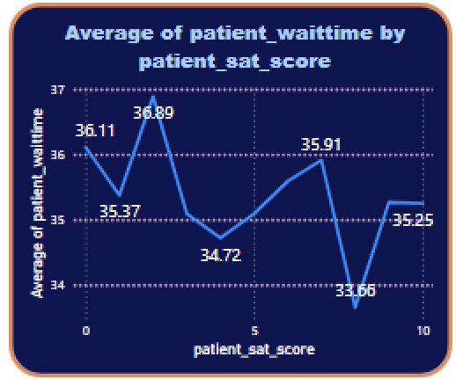

Data does not show any significant relation between patient wait time and satisfaction scores.

1. How do patient demographics affect the frequency of visits to different departments?

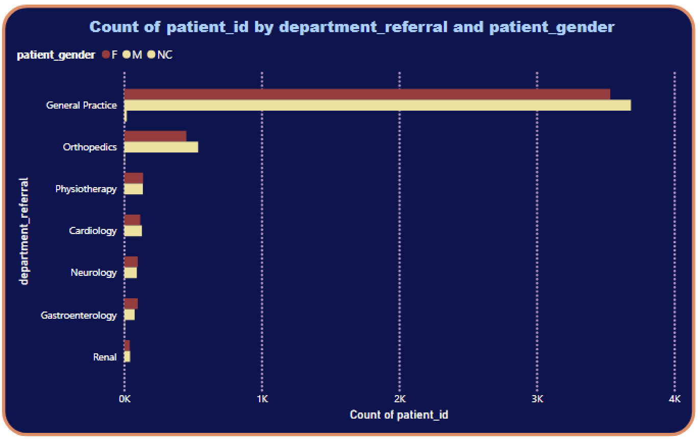

In general practice department number of female patients are 3535 and male patients are 3685, which is maximum among all the departments. Followed by orthopedics department.

1. Is there a noticeable trend in the volume of patient visits throughout the year?

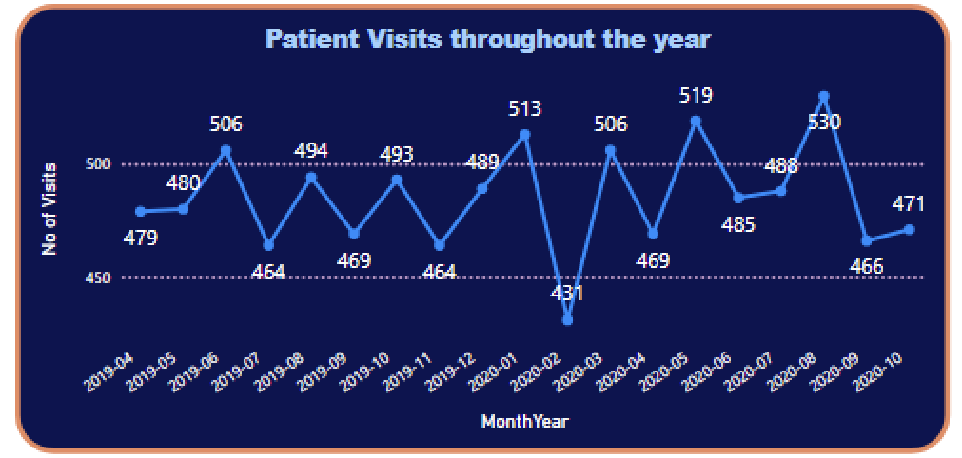

From the data we can clearly see that no. of visits of patients follows a zig-zag pattern which increases and then decreases. Still from the above data we can clearly see that of visits in hospital is maximum in 2020-08 (Month Year) i.e 530 visitors and lowest in March 2020 which is 431 patients.

4.)Which age groups report the highest and lowest satisfaction scores?

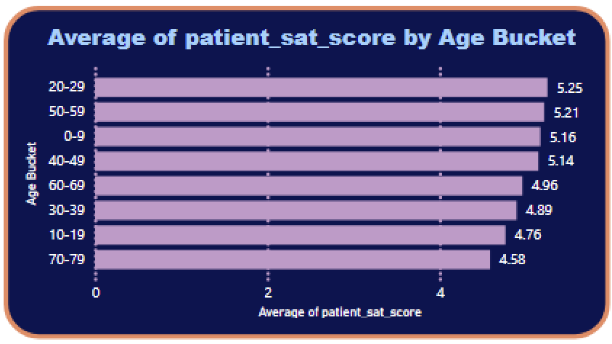

From the above data we can clearly see that Patients in the age group of 20-29 has the highest satisfaction rate i.e 5.25 and Patients in the age group of 70-79 has the lowest satisfaction rate.

5.)Say someone outside of the hospital claims that there is racial or gender-based discrimination in the hospital, how will you identify whether the claim was right or not?

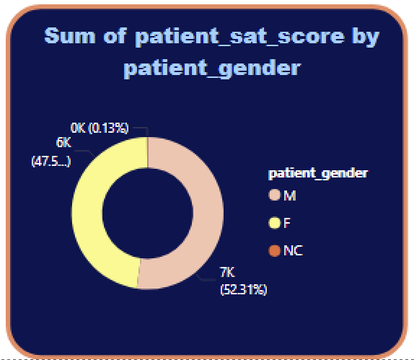

If someone outside of the hospital claims that there is racial or gender-based discrimination in the hospital, then we can support our credibility by providing this visualization in which satisfaction score of both male and female patients is 5 and equal.

6.) The hospital management intends to offer discounts to patients. How should these offers/discounts be assigned to patients, on what basis, and why?

1. Loyalty Program :- Reward frequent patients with discounts after a certain number of visits or treatments.

example: After every 5 visits, offer a 10% discount on the next appointment.

Benefit: Encourages repeat visits and enhances patient loyalty.

2. Referral Program :- Provide discounts to patients who refer others to the hospital or clinic. It will benefit by increasing new patient acquisition through word-of-mouth marketing.

example: Give a 15% discount on the next appointment when a patient successfully refers a new patient.

3. Early Payment Discounts :- Offer a discount for patients who pay their bills early.This will benefit the hospital by improving the cash flow and reducing accounts receivable.

example: Provide a 5% discount for payments made within 5 days of receiving the bill.

7.) The hospital has a budget to hire 2-3 new doctors. They have asked for your suggestions on which departments they should hire.

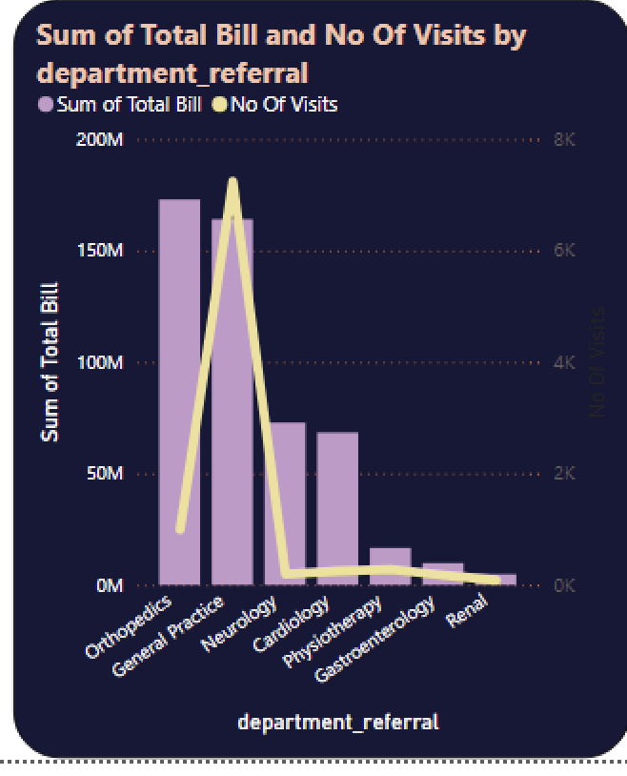

Hospital should hire one doctor of General Practice department, second of Neurology department and 3rd of Orthopedics as both the number of visits and revenue is large in these departments which are crucial for success of hospital.

8.) Is the hospital profitable? How will you determine the profitability?

Ans:-) To determine whether a hospital is profitable using Power BI, you can analyze the hospital's revenue and expenses over a period of time. Here's a scenario and how profitability can be calculated:

Scenario:

For this we will be analyzing the financial performance of a hospital for the past year. The hospital's dataset includes fields like:

Date (when services were provided)

Department (where services were provided)

Doctor Name

Appointment Fees (revenue generated per patient)

Total Bill (the total revenue from treatments)

Operational Costs (fixed or variable costs for running each department)

Staff Salary (monthly salary per doctor and staff member)

Supplies Cost (medical supplies, equipment maintenance)

Miscellaneous Expenses (utilities, insurance, administrative costs)

The goal is to determine whether the hospital is profitable and where profitability can be improved.

Approach to Determine Profitability:

Define Profitability Formula:

Profit = Total Revenue − Total Expenses

9.) Any Department for which the waiting time is oddly large?

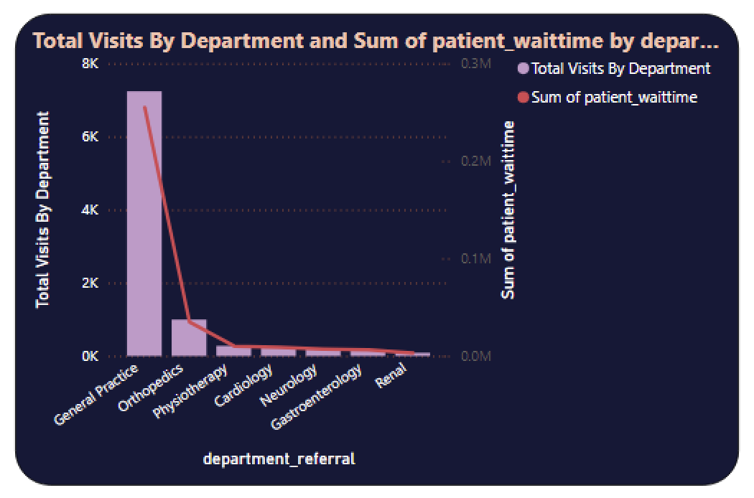

From this we can clearly say that General Practice department has oddly large waiting time , which is justifiable as number of visits is largest in general practice department . So, is the waiting time.

10.) Come up with strategies to provide discounts to the patients.

To create effective discount strategies for patients, it's essential to consider various factors like patient demographics, treatment types, and frequency of visits. Here are several strategies that can be implemented:

1. Loyalty Program :- Reward frequent patients with discounts after a certain number of visits or treatments.

example: After every 5 visits, offer a 10% discount on the next appointment.

Benefit: Encourages repeat visits and enhances patient loyalty.

2. Referral Program :- Provide discounts to patients who refer others to the hospital or clinic. It will benefit by increasing new patient acquisition through word-of-mouth marketing.

example: Give a 15% discount on the next appointment when a patient successfully refers a new patient.

3. Early Payment Discounts :- Offer a discount for patients who pay their bills early.This will benefit the hospital by improving the cash flow and reducing accounts receivable.

example: Provide a 5% discount for payments made within 5 days of receiving the bill.

4. Seasonal Promotions :- Implement discounts during specific times of the year when patient visits might be lower (e.g., summer or holiday seasons).This will benefit by driving traffic during slower periods and helps manage patient volume.

Example: Offer a 20% discount on health checkups during winter holidays.

5. Bundled Discounts:- Offer discounted packages for patients who need multiple treatments or services.This will benefit by encouraging patients to commit to long-term treatment plans and increase overall revenue per patient.

6. Group Discounts:- Provide discounts for families or groups who schedule appointments together.This will benefit the hospital by group visits and improves the clinic's utilization rates.

Benefit: Attracts group visits and improves the clinic's utilization rates.

7. Senior and Student Discounts:- Offer specific discounts to seniors, students, or other demographics.This will help by Building goodwill with specific demographics and fosters long-term relationships.

Example: Provide a 15% discount on appointments for patients over 60 or students with valid IDs.

8. First-Time Patient Discount:- Attract new patients by offering a discount on their first visit.This reduces the barrier to entry and attracts new patients.

Example: 20% off for first-time consultations or treatments.

10. Membership Program:- Introduce a subscription-based membership that provides patients with regular discounts or services. This benefits by ensuring recurring revenue while offering value to frequent patients.

Example: For a monthly fee, patients get a 20% discount on all treatments and priority scheduling.

11.) Say you need to align the doctors of the “General Practice” department to work in one of the two shifts, how will you identify what will these two shifts' timings be, and how will you divide the doctors in these two shifts? And also will this 2 shift policy be helpful for the hospital?

Ans:-) From this we can clearly see that there are a total 6 “General Practice” department doctors in which 3 doctors can work in day shift (AM) and 3 doctors work in night shift (PM) .

Here i have divided the doctors in 2 shifts according to AM and PM from the time given and from the visualization below we can clearly see three doctors working in A.M time slot and 3 doctors working in P.M time slot.

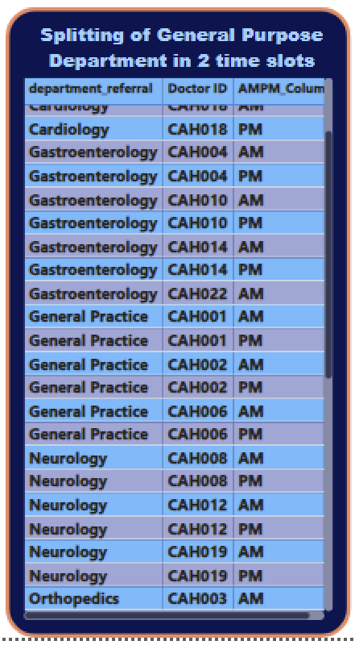

12.)What do you understand about the PowerBI gateway? What are its use cases?

Ans:-) A Power BI Gateway is a bridge that allows secure data transfer between on-premises data sources and the Power BI cloud service. It thus ensures that data is updated and synced for reports and dashboards without needing to move the data to the cloud.

Use Cases:

Real-Time Data Access: Enables connection to on-premises databases (like SQL Server) for real-time reporting.

Scheduled Data Refresh: Automates data refresh for Power BI reports from on-premises sources.

Hybrid Scenarios: Supports hybrid environments where data is stored both on-premises and in the cloud.

13.) How would you approach this problem, if the objective and subjective questions weren't given?

Ans:- If the objective and subjective questions are not given, then i would first clearly define the business problem or analysis goal, gather relevant data, and explore it to identify key metrics and trends. I would then build visualizations in Power BI to answer potential questions, using filters, DAX calculations, and custom measures to uncover insights.

14.)Can you analyze and write the type of relationship between the doctor id and department, is it one-to-one?

Ans:- ) from the visualization we can clearly see that there is a one to one relation between doctor id and department except for one doctor which work in 3 department.

